Lab – 5

1. Write a C program to store 5 values in an array, reverse the array and store value in another array. Print the reversed array.

#include <stdio.h>

int main()

{

int arr1[5], arr2[5], i;

printf("Enter the elements in the array :\n");

for(i=0; i<5; i++){

scanf("%d", &arr1[i]);

}

printf("The original array : ");

for(i=0; i<5; i++){

printf("%d", arr1[i]);

}

for(i=0; i<5; i++){

arr2[i]=arr1[4-i];

}

printf("\n");

printf("The reversed array : ");

for(i=0; i<5; i++){

printf("%d", arr2[i]);

}

return 0;

}

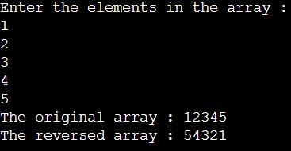

2. Write a program in C to find the sum of all elements of the array.

#include <stdio.h>

int main()

{

int arr[5], i, sum=0;

printf("Enter the elements in the array :\n");

for(i=0; i<5; i++){

scanf("%d", &arr[i]);

}

printf("The original array : ");

for(i=0; i<5; i++){

printf("%d", arr[i]);

}

printf("\n");

printf("The sum of elements in the array is : ");

for(i=0; i<5; i++){

sum += arr[i];

}

printf("%d", sum);

return 0;

}

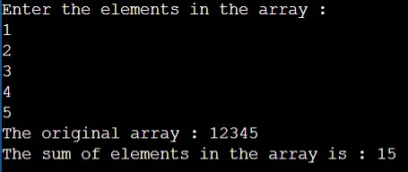

3. Write a program in C to count a total number of duplicate elements in an array.

#include <stdio.h>

int main()

{

int arr[10], i, j, count=0;

printf("Enter the elements in the array :\n");

for(i=0; i<10; i++){

scanf("%d", &arr[i]);

}

printf("The original array : ");

for(i=0; i<10; i++){

printf("%d", arr[i]);

}

printf("\n");

printf("The number of duplicate elements in the array is : ");

for(i=0; i<10; i++){

for(j=i+1; j<10; j++){

if (arr[i] == arr[j]){

count += 1;

break;

}

}

}

printf("%d", count);

return 0;

}

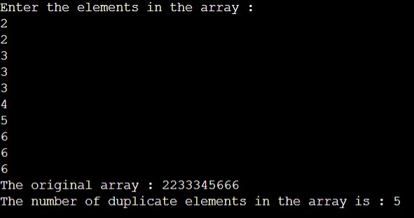

4. Write a program in C to arrange array in ascending order.

#include <stdio.h>

int main()

{

int arr[10], i, j, min;

printf("Enter the elements in the array:\n");

for(i=0; i<10; i++){

scanf("%d", &arr[i]);

}

printf("The original array: ");

for(i=0; i<10; i++){

printf("%d", arr[i]);

}

for(i=1; i<=10; i++){

min = arr[i];

j = i-1;

while (j >= 0 && arr[j] > min)

{

arr[j + 1] = arr[j];

j = j - 1;

}

arr[j + 1] = min;

}

printf("\nThe sorted array: ");

for(i=0; i<10; i++){

printf("%d", arr[i]);

}

return 0;

}

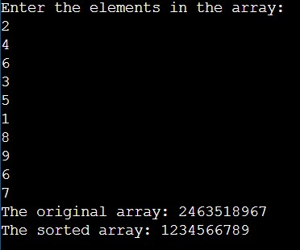

5. Write a program in C for addition of two Matrices of same size.

#include <stdio.h>

int main()

{

int r1, c1, r2, c2, i, j;

printf("Enter the number of rows in the first matrix: ");

scanf("%d", &r1);

printf("Enter the number of columns in the first matrix: ");

scanf("%d", &c1);

int m1[r1][c1];

printf("\nEnter the elements in the first matrix :\n");

for(i=0; i<r1; i++){

for(j=0; j<c1; j++)

scanf("%d", &m1[i][j]);

}

printf("\nEnter the number of rows in the second matrix: ");

scanf("%d", &r2);

printf("Enter the number of columns in the second matrix: ");

scanf("%d", &c2);

if ( (r1 == r2) && (c1 == c2) ){

int m2[r2][c2];

printf("\nEnter the elements in the second matrix :\n");

for(i=0; i<r2; i++){

for(j=0; j<c2; j++)

scanf("%d", &m2[i][j]);

}

printf("\nThe first matrix :\n");

for(i=0; i<r1; i++){

for(j=0; j<c1; j++)

printf("%d\t", m1[i][j]);

printf("\n");

}

printf("\nThe second matrix :\n");

for(i=0; i<r2; i++){

for(j=0; j<c2; j++)

printf("%d\t", m2[i][j]);

printf("\n");

}

printf("\nThe sum of the matrix :\n");

for(i=0; i<r1; i++){

for(j=0; j<c1; j++)

printf("%d\t", m1[i][j]+m2[i][j]);

printf("\n");

}

}

else

printf ("Matrices with entered orders can't be added with each other.");

return 0;

}

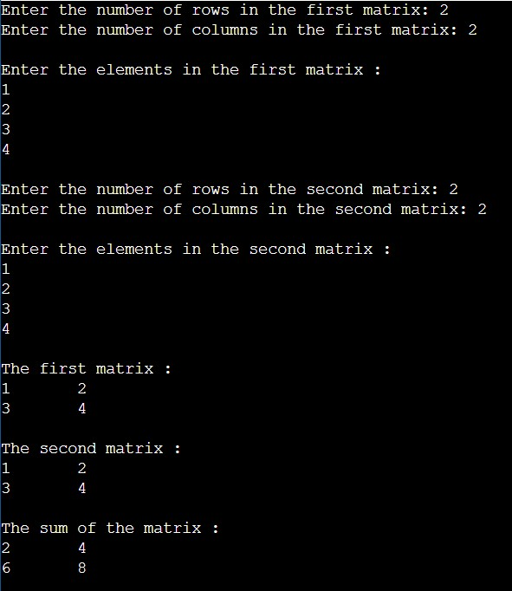

6. Write a program in C for multiplication of two square Matrices.

#include<stdio.h>

int main()

{

int r1, c1, r2, c2, i, j, k, sum=0;

printf("Enter the number of rows in the first matrix: ");

scanf("%d", &r1);

printf("Enter the number of columns in the first matrix: ");

scanf("%d", &c1);

int m1[r1][c1];

printf("\nEnter the elements in the first matrix :\n");

for(i=0; i<r1; i++){

for(j=0; j<c1; j++)

scanf("%d", &m1[i][j]);

}

printf("\nEnter the number of rows in the second matrix: ");

scanf("%d", &r2);

printf("Enter the number of columns in the second matrix: ");

scanf("%d", &c2);

int m2[r2][c2];

int multiplication[r1][c2];

(c1 != r2)?

(printf("Matrices with entered orders can't be multiplied with each other.\n")):

(

{

printf("\nEnter the elements in the second matrix :\n");

for(i=0; i<r2; i++){

for(j=0; j<c2; j++)

scanf("%d", &m2[i][j]);

}

printf("\nThe first matrix :\n");

for(i=0; i<r1; i++){

for(j=0; j<c1; j++)

printf("%d\t", m1[i][j]);

printf("\n");

}

printf("\nThe second matrix :\n");

for(i=0; i<r2; i++){

for(j=0; j<c2; j++)

printf("%d\t", m2[i][j]);

printf("\n");

}

for(i=0; i<r2; i++){

for(j=0; j<c1; j++){

for(k=0; k<c2; k++){

sum = sum + m1[i][k]\*m2[k][j];

}

multiplication[i][j] = sum;

sum = 0;

}

}

printf("\nThe multiplication of the two matrices :\n");

for ( i = 0 ; i < r1 ; i++ ){

for ( j = 0 ; j < c2 ; j++ )

printf("%d\t", multiplication[i][j]);

printf("\n");

}

}

);

return 0;

}

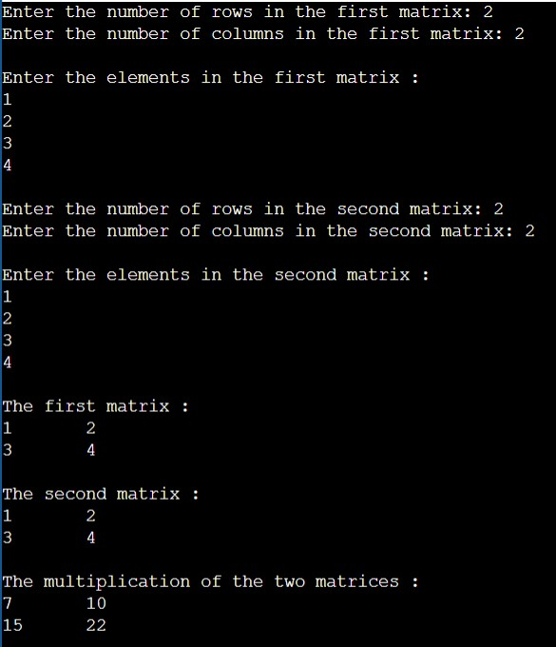

7. Write a program in C to find transpose of a given matrix.

#include <stdio.h>

int main()

{

int r, c, i, j;

printf("Enter the number of rows in the first matrix: ");

scanf("%d", &r);

printf("Enter the number of columns in the first matrix: ");

scanf("%d", &c);

int m1[r][c];

printf("\nEnter the elements in the first matrix :\n");

for(i=0; i<r; i++){

for(j=0; j<c; j++)

scanf("%d", &m1[i][j]);

}

int m2[c][r];

for(i=0; i<c; i++){

for(j=0; j<r; j++)

m2[i][j]=m1[j][i];

}

printf("\nThe matrix :\n");

for(i=0; i<r; i++){

for(j=0; j<c; j++)

printf("%d\t", m1[i][j]);

printf("\n");

}

printf("\nThe transpose of the matrix :\n");

for(i=0; i<c; i++){

for(j=0; j<r; j++)

printf("%d\t", m2[i][j]);

printf("\n");

}

return 0;

}

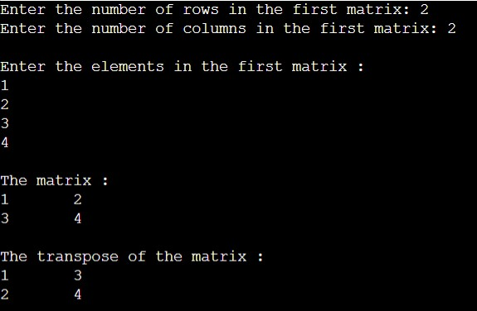

8. Write a function in C which will take array as an argument and return sum of all elements of that array.

#include <stdio.h>

int sum (int a[], int n){

int i,sum=0;

for(i=0; i<n; i++)

sum+=a[i];

return sum;

}

int main()

{

int len, i, result;

printf("Enter the length of the array: ");

scanf("%d", &len);

int arr[len];

printf("Enter the elements in the array :\n");

for(i=0; i<len; i++)

scanf("%d", &arr[i]);

printf("\nThe array : ");

for(i=0; i<len; i++)

printf("%d ", arr[i]);

result = sum(arr,len);

printf("\nSum of elements in the array is = %d",result);

return 0;

}

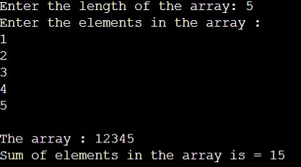

9. Write a function in C which will take a 3x3 matric as argument and print determinant of that matrix.

#include <stdio.h>

void det(int a[3][3]){

int determinant;

determinant = a[0][0] \* ((a[1][1]\*a[2][2]) - (a[2][1]\*a[1][2])) -a[0][1] \* (a[1][0]\* a[2][2] - a[2][0] \* a[1][2]) + a[0][2] \* (a[1][0] \* a[2][1] - a[2][0] \* a[1][1]);

printf("\nThe determinant of the matrix : %d", determinant);

}

int main()

{

int i, j, m1[3][3];

printf("\nEnter the elements in the first matrix :\n");

for(i=0; i<3; i++){

for(j=0; j<3; j++)

scanf("%d", &m1[i][j]);

}

printf("\nThe matrix :\n");

for(i=0; i<3; i++){

for(j=0; j<3; j++)

printf("%d\t", m1[i][j]);

printf("\n");

}

det(m1);

return 0;

}

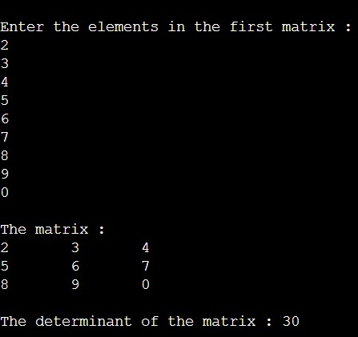

10. Write a function in C which will take 2 2-D matrices as argument ad print sum of those two matrices.

#include <stdio.h>

void sum(int r1, int c1, int r2, int c2, int arr1[r1][c1], int arr2[r2][c2]){

int i,j;

printf("\nThe sum of the matrix :\n");

for(i=0; i<r1; i++){

for(j=0; j<c1; j++)

printf("%d\t", arr1[i][j]+arr2[i][j]);

printf("\n");

}

}

int main()

{

int r1, c1, r2, c2, i, j;

printf("Enter the number of rows in the first matrix: ");

scanf("%d", &r1);

printf("Enter the number of columns in the first matrix: ");

scanf("%d", &c1);

int m1[r1][c1];

printf("\nEnter the elements in the first matrix :\n");

for(i=0; i<r1; i++){

for(j=0; j<c1; j++)

scanf("%d", &m1[i][j]);

}

printf("\nEnter the number of rows in the second matrix: ");

scanf("%d", &r2);

printf("Enter the number of columns in the second matrix: ");

scanf("%d", &c2);

if ( (r1 == r2) && (c1 == c2) ){

int m2[r2][c2];

printf("\nEnter the elements in the second matrix :\n");

for(i=0; i<r2; i++){

for(j=0; j<c2; j++)

scanf("%d", &m2[i][j]);

}

printf("\nThe first matrix :\n");

for(i=0; i<r1; i++){

for(j=0; j<c1; j++)

printf("%d\t", m1[i][j]);

printf("\n");

}

printf("\nThe second matrix :\n");

for(i=0; i<r2; i++){

for(j=0; j<c2; j++)

printf("%d\t", m2[i][j]);

printf("\n");

}

sum(r1,c1,r2,c2,m1,m2);

}

else

printf ("Matrices with entered orders can't be added with each other.");

return 0;

}

